THE

MIGHTY B.C. CAMP

2012.
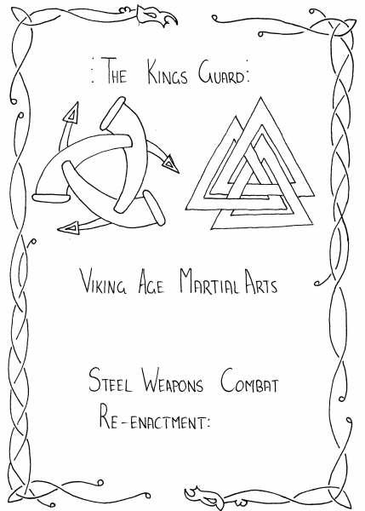
Hail All North men and Dark Age people of New Zealand, come and unite under the Banner of the B.C. for a weekend of merriment and feasting.
Where we can all combine together, for a common goal.
To create a Dark Age encampment and Thyng.
This is a camp for all, and we except everyone to get involved in making things happen. After all this is your camp so what you put in is what you get out.

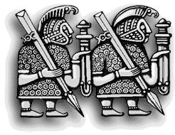
This will be the Forth Annual Thyng and weekend of feasting, fighting and good company. There will be combat for all, archery, axe and knife throwing, games, drinking and story telling. Throughout the weekend there will be an ongoing market which we encourage all encampments to sell their wares. The main focus of the weekend will be on re uniting the ties of old friends and putting together a period encampment. This time round there will be a few more games and things to do. If you wish to run anything just let us know and all should be good.

WERE: Tokoroa Clay targets (Gun) Club. Miratae Road heading south from Hamilton its the Main road on the right after the Mobile service station
WHEN: 19th, 20th^{th} 21th, 22nd, October 2012
WHY: Cause we can.
HOW: Blood, sweat and tears with your support.
WHO: YOU!
COSTS: Camp fee for whole weekend including camp site $30.00 per head.
Children under 8 Free.
This is to be paid at least two weeks prior to the camp start as there will be no door sales or pay on the days, so the rule is no pre pay no stay.
Day trippers $5.00 per head
Just for the feast only $15.00 per head
Account to put Money Into: make it to
The Mighty B.C.
ASB 12-3454-0046752-50
put you name as a reference so we know you payed.

ACCOMMODATION: “by camp site, preferably period tents only”
Plastic/farb tents by arrangement. Set up will commence on Friday the 19th 10am, pack up on Monday the 22nd We have NO soft accommodation available.
FOOD: “there will be a feast on the Sunday night”
This year for the feast we are getting you to cook your own feast we are asking the every body either as a club or indivduals prepare a dish worthey of the feast and place it on the feasting table.
All other meals will be your own responsibility and we will expect you to prepare this in your encampment in an authentic as possible fashion. There will be washing up facilities available, so with this in mind remember fire, fire wood and fire safety. There will be no fridge or any form of kitchen facilities we do have toilets and clean cold running water.

SITE: “We see this as our house and you have come to play”
There are rules and if you don’t like them don’t come. There will be rubbish bins provided so use them as cans and bottles on the ground will not be tolerated. There is games and fun for all so enjoy, if you’re not sure ask.
We do ask that you camp in club groups or small groups around one common fire pit.
CHILDREN: “Hopefully there will be lots of little takers running around”
We will have some games and entertainment for the wee ones but first and foremost if they’re your kids they’re your responsibility so look after them and if they’re not yours look out for them.
GAMES: There will be a number of games and competitions, you are all encouraged to join in and help make these events possible and fun.
FIRE: The BC will not be suplying fire wood so bring your own if you want fire. You may dig fire pits.
There will be two Competition Fights.
- Sword and shield Vs Sword and shield Holmgang.
- A knife fighting competition, wooden knives.
The rules are as follows.
Holmgang - Sword and shield Vs Sword and shield. B.C. rules of combat apply. One on one fight in a knock out system. Each fight will be judged by two refs, each clean kill you make on your opponent will count as one point. First to 3 points wins and the winner moves on to the next round. Referees decision is final.
Holmgang - knife fighting competition. With wooden knives only. Same as above but will be bare shirt. Knee down and elbow down shots will not count as a kill. No head shots. Wooden knives may be supplied.
All Fights will be held in a Holmgang arena any stepping out of this area will count as a point against you.
May Ullr Save You

CONTACT:

Pee Wee
(Hamilton)
Mobile: 021 251 6457
E – Mail: kings_huscarl@hotmail.com


map to get there
MAY ODD GUIDE YOU!
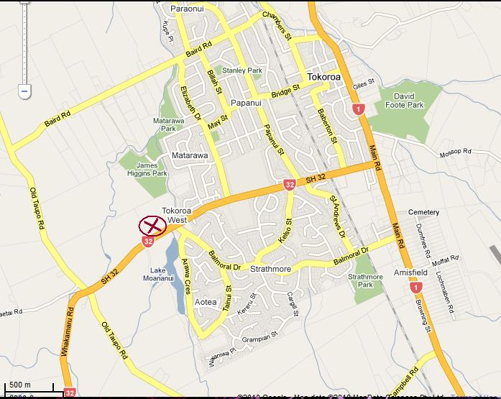

B.C. COMBAT RULES.
These are the combat rules. They are compulsory and we reserve the right to exclude any person or persons not adhering to the following:
GENERAL:
All participants are expected to wear historical kit at the event at all times. Dark Ages kit only please. Your club, Captain/Leader MUST vouch for your armor, weapons and general level of training before you step onto the field. Should anything occur, the B.C. WILL be taking it up with him/her and retain the right to refuse entry onto the field or removal from all combat.
MINIMUM ARMOUR REQUIREMENTS:
- Steel helmets, preferably full face suspension helms. Head blow capable.
- Gloves preferably armored.
- Additional defenses are at the discretion of the participant. We strongly advise body protection (Chain or Lamellar), greaves, vambraces, etc.

COMBAT EQUIPMENT SPECIFICATIONS:
- All weapons must be in a safe, well maintained state upon entry in the competitions and at all times during the event
- Marshals will check for use/wear throughout the tournament
- All edges and points must be blunted to a “safe” standard (if you wouldn’t use it at any other event, don’t try it here either!!)

GENERAL COMBAT RULES:
- Marshals' decisions are final and incontestable. Contesting decisions during combat may result in removal from the field or for the duration of the event.
- No fighter under the age of 16 may take part in combat…unless with our permission and that of their parent/guardian and the head marshal.
- Fighters must, if challenged; be able to provide two references for their safety and skill. These references must come from recognized club captains or trainers.

TARGET ZONES:
- Arms from 2 (two) inches above the wrist, avoiding the elbows.
- Legs from 2 (two) inches above the ankle, avoiding the knees.
- Torso, avoiding the spine, kidneys and liver
- Head. Downwards crown blow ONLY! During head blow combat ONLY!
- All blows struck should be with force sufficient to the level of protection worn in the combat, and blows struck without control are actively discouraged. Weak, ineffective or inconclusive blows may be ignored…having said this, you have honor, USE IT, if you know someone pulled the blow, take it.
- Grapples and throws resulting in an opponent being grounded count as a killing blow…no extended wrestling matches please. ☺

SAFETY:
- No blow is to be thrown that seeks intentional harm to an opponent…no “accidents” either.
- No strikes to the sides or back of the head and neck are permitted. Period.
- NO shots to the FACE.
- No groin strikes.
- Accidental blows to non-target areas will still count as kills…extended use of these movements will see the combatant removed from the field.
- Unsafe combatants, as deemed by a Marshall, will be removed from the field. Objections may be brought to the BC AFTER combat is over. We advise bringing your Instructor.

Semi Final Note: Death: if you are hit you are expected to die the best and most spectacular death you can. This means laying down dead on the ground. Any one caught just sitting or walking off will be getting lessons on how to die.
Final Note: these are the rules, don’t like em don’t fight or go elsewhere, simple as that.

All complaints, moans whinges should be forwarded in triplicate and marked S for shredder thank you.
Hail all may the All Father receive you well.

N.B. The B.C. reserves the right to do anything they want.

